**PROJECT PROPOSAL**



**Spring 2022**

**CSE102L Computer Programming Lab**

Suleman Shah (**21PWCSE1983)**

Shahzad Bangash (**21PWCSE1980)**

Ali Asghar (**21PWCSE2059)**

“On my honor, as student of University of Engineering and Technology, I have neither given nor received unauthorized assistance on this academic work.”

Submitted to:

**Engr. Abdullah Hamid**

July 5, 2022

Department of Computer Systems Engineering

University of Engineering and Technology, Peshawar

**SOCCER PINBALL GAME**

**SOCCER PINBALL:**

Soccer Pinball Game blends the challenges of soccer and pinball in one game. It is a hyper-casual game with fun and challenging mixed gameplay of soccer and pinball. This game truly fulfills the desire of both soccer and pinball game fans.

**HYPER-CASUAL GAME:**

A **hyper-casual game** is a lightweight game with minimal design. They are relatively easy to produce, but they guarantee to offer a high level of entertainment and enjoyment.

**FRAMEWORK:**

Unity and C#.

**CLASSES AND STRUCTURES USED IN PROJECT**

By using Unity and C# as a framework, we will design this project using the concept of object-oriented programming. Following classes are

1. Game Manager
2. Sound Manager
3. Interface Manager
4. Player Controller
5. Goals controller

And many more classes for game flexibility.

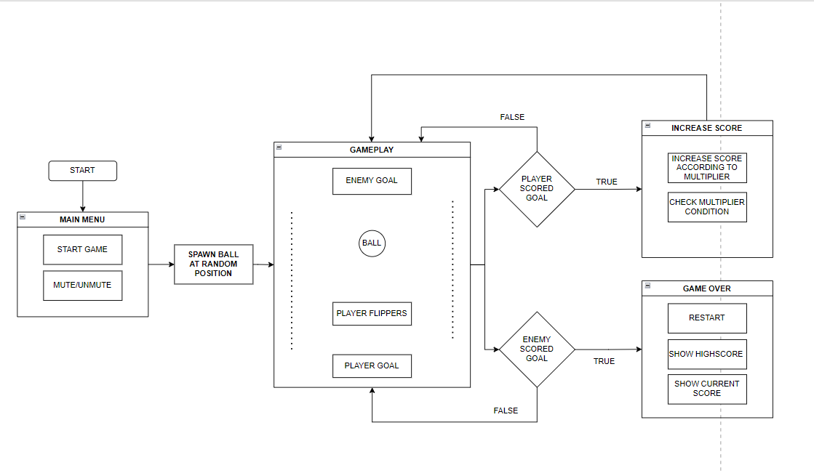

**GAME FLOWCHART**